STAT420
HW2
Yizhan Ao
Q1: The company should select buying the rights to the South Beach Diet
Q2: From the T test, we have the Difference: WEIGHT_BEFORE - WEIGHT_AFTER the that is reduced to 7.1667 after we select the South Beach Diet. On the confidence level 95% we have the p value of the difference is p-value=0.0212/2=0.0106. We can have the accepted p value < 0.05 from the one-sided t test but the result is corresponding to the two-sided test. Therefore, the company should accept South Beach Diet.
Q3: We have used T-test. The T-hypothesis testing needs data from the normal distribution. WEIGHT_BEFORE - WEIGHT_AFTER, is the normal distribution. From the UNIVARIATE procedure we can see the distribution of (WEIGHT_BEFORE - WEIGHT_AFTER) is the normal. So we can use the UNiVRIATE procedure in the analysis. The distribution of WEIGHT_BEFORE is normal. Because the P values of Shapiro Wilk Test, Kolmogorov-Smirnov test, Cramer-von Mises test, and Anderson-Darling test are all greater than 0.05 given the confidence interval 95%. Meaning we have the H0 to be accepted . Therefore we have the distribution of WEIGHT_BEOFRE to be the normal

The following picture shows that we have 95% confidence so that the difference follows a normal distribution.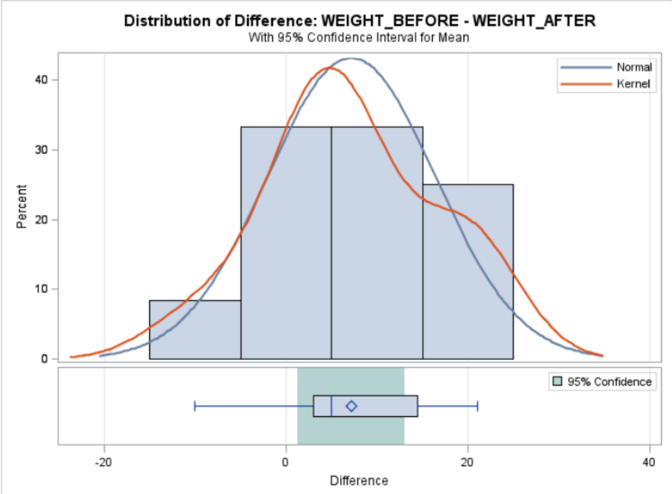
Similar to the WEIGHT_BEFORE, the distribution of WEIGHT_AFTER is also a normal since the P value of all four values of normality tests are greater than 0.05, and we can also use the box plot to tell the probability as well.
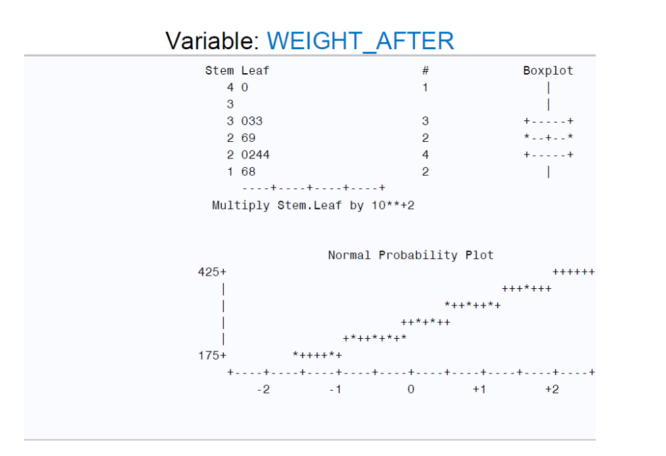
WEIGHT BEFORE and WEIGHT AFTER also have a linear connection. If a patient weighed more before starting the diet, they will lose more weight during it.
